**Morgan State University**

Quantum Laboratory Sequence

Quantum Lab #3: Single Photon Interference

**Reference: Textbook Section**

**Motivation**

[For Eric]

**Background**

Classical light behaves differently from non-classical photons, in particular for single photons. As a classical example, consider light, whether from a thermal source or a laser beam, interacting with a 50:50 beam splitter (i.e. half the light is reflected and half is transmitted), as shown in Fig. 1. In this classical physics case, one would expect equal intensities at detectors 1 and 2, and indeed this is the result of such a setup. However, the result is completely different for the case of a single photon entering the beam splitter, since a single photon is a very quantum particle and will behave in an unexpected quantum manner.

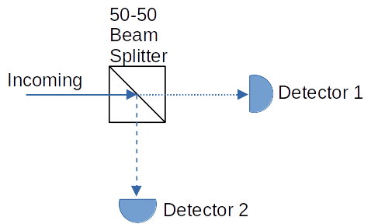

**Figure 1.** Incoming classical light is split 50:50 into transmitted and reflected light received by detectors 1 and 2, respectively.

To better understand how a single photon will behave through a beam splitter, some quantum operator theory is helpful. Consider the four ports of a beam splitter as shown in Fig. 2. Let the quantum state be represented as a "ket" containing the number of photons. For example, port 1 with zero photons is represented as. Let the quantum "annihilation" operatorrepresent the loss of a photon. For example, assume port 1 has one incoming photon, represented as. The removal of this photon is done by operating on this state by annihilation operator, namely. Note that the subscripts should match to keep track of the operator on specific ports. To create a photon, we use the photon "creation" operator , which is the adjoint of. For example, to create another photon into port 1, the equation is, which shows that now port 1 has 2 photons entering it.

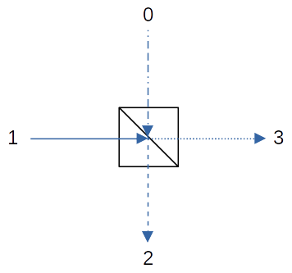**Figure 2.** Illustration of a beam splitter with four ports labeled 1, 2, 3 and 4. Ports 0 and 1 are input ports and ports 2 and 3 are output ports.

An amazing fact is that photons can be created out of the vacuum, and in fact this quantum vacuum is a necessary aspect of quantum mechanics, including the explanation for spontaneous emission. The equation to create a photon from the vacuum entering port 1, for example, is.

Now, let's investigate how a single photon entering a beam splitter will behave. To start, assume only vacuum at all ports, i.e.,,,and. Let's create a single photon entering port 1, and assume vacuum at port 0:

(1)

As you can see, the creation operatoroperates on the vacuum stateassociated with port 1, but not on port 0, which is still the vacuum state.

Referring again to Fig. 2, the creation operator for the output port 2 depends on the photon entering the beam splitter from ports 0 and 1, namely

(2)

and similarly for output port 3:

(3)

The imaginary *i* stems from the reflection off the dielectric coating inside the beam splitter.

Now we can use Eqs. (2) and (3) to solve for in terms of and :

(4)

The relation connecting the ports of the beam splitter can be written as

(5)

Now we can multiply both sides of Eq. (5) by , and using Eq. (4):

(6)

The resulting wave function representing the output of the beam splitter for an incoming photon at port 1 is thus

(7)

You may recognize Eq. (7) as being similar to the entangled state for horizontal and vertical polarizations, as reproduced below as Eq. (8).

(8)

In fact, Eq. (7) represents an entangled state between the vacuum and a single photon produced at exit ports 2 and 3 as a result of the entry of a single photon at port 1 (and vacuum at port 0). The consequence of Eq. (7) means that detectors placed at the exit ports 2 and 3 of the beam splitter will register a photon at either detector 2 *or* detector 3, but never at both simultaneously (i.e. no coincidence counts). In other words, **the single photon entering port 1 will remain a single photon upon exiting the beam splitter, and thus behaves like a *particle***.

The probability that a photon will be detected at port 2 is given by bracketing Eq. (7) with thestate of a single photon in port 2, and taking the square:

(9)

and similarly the probability of detecting the photon in port 3 is also 50%.

**Wave-like Photon Experiment**

Now, what happens if we add another beam splitter, as shown in Fig. 3? The setup in Fig. 3 is called a Mach-Zehnder interferometer. Assume as before that vacuum is at port 0 of the first beam splitter in Fig. 3, and create a single photon entering port 1, denoted as, as the entry state into the Michelson interferometer. On the upper leg we add a phase shifter that adds a phase q to the wave function for that arm. Now allow the photon number states emanating from the first beam splitter enter the second beam splitter having analogous ports 0', 1', 2' and 3'.

Using the same beam splitter creation operators as before, but for the inputs as indicated in Fig. 3 entering the second beam splitter, results in the quantum state of the output ports 2' and 3' being

(10)

where *q*0 is an arbitrary phase. Equation (10) also represents an entangled state, but with oscillations through the sine and cosine terms. The probability of detecting a single photon at port 2' or port 3' are similarly calculated as before, resulting in Eqs. (11). Thus, the probability of detecting a signal oscillates depending on the imparted phase shift *q*, indicative of the *interference of a wave* (the arbitrary phase *q*0 has been ignored).

(11a)

(11b)

As we have shown, a single photon entering a single beam splitter results in particle-like behavior of the emanating photon (i.e. a single photons exits one port or the other intact), **but by adding another beam splitter to make an interferometer results in the photon behaving as a wave** (i.e. the detector at either exit port will show oscillation fringes as *q* changes). This is the weirdness of quantum mechanics.

**Figure 3.** A Mach-Zehnder interferometer that causes single-photon interference at the output ports of the second beam splitter.

0

1

2

3

0’

1’

2’

3’



While a Mach-Zehnder interferometer was used above to illustrate single-photon interference, a Michelson interferometer provides the same effect, but by re-using the first beam splitter, as shown in Fig. 4. Since either port exit will contain the oscillating signal, just monitoring one port of the beam splitter (in this case port 0) will provide the oscillation data we desire.

**Figure 4.** Illustration of a Michelson interferometer where mirrors are used to reflect the outputs of the beam splitter back into the beam splitter, which has the same photon interference outcome as the Mach-Zehnder interferometer.

0

1

2

3

Mirror

Mirror

By varying the length of one leg of the interferometer, interference fringes will appear, as shown in Fig. 5 (Note that Fig. 5 was recorded with a motor attached to the quED-MI platform, which is not included with this lab setup). A portion of the large-sweep fringe is highlighted in the inset within Fig. 5, and will be the focus of the measurement of this lab.

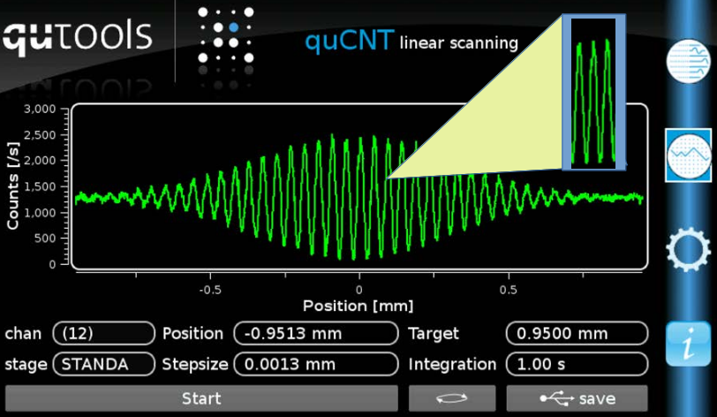

**Figure 5.** An example recording of a large sweep of interferometer arm length, illustrating the interference fringes and thus wave-like nature of photons.

**Lab Setup**

A schematic view of the Michelson interferometer setup can be seen in Fig. 5. Note that correlated photon pairs exit the quED section, with one being connected to APD 1 as a coincidence signal for when to take a measurement, and the other photon heading to the quED-MI interferometer. The output from one port of the Michelson interferometer is used as the wave interference signal attached to APD 2. Thus the quCR records counts only when the Michelson photon signal arrives at the time triggered by APD 1.

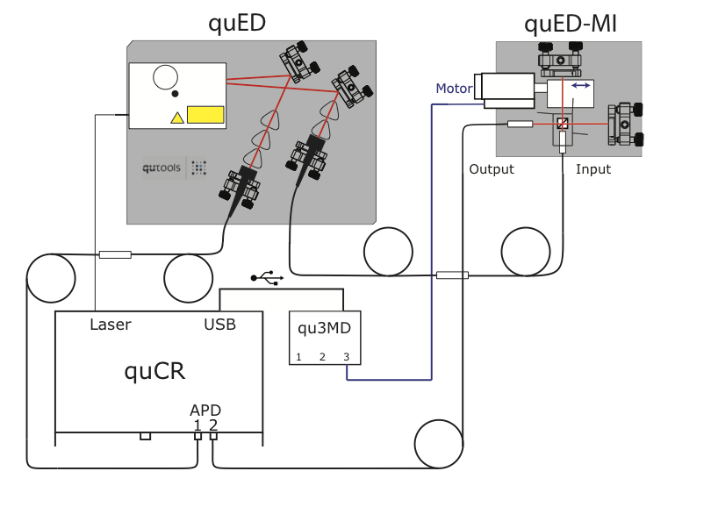**Figure 5.** The setup of the single photon experiment with all necessary connections.

**Generate Photon Pairs**

Remove the half wave plate (HWP) from the laser source:

* 1. Go to the Laser Diode menu and turn the current down to 0 mA.
  2. Press the red laser LED so that the laser head is turned OFF (the red LED should be dimmed).
  3. loosen the top bolt with your hand, remove the white cover, and carefully remove the HWP with tweezers.
  4. Replace the white cover and hand tighten the bolt.
  5. Press the red laser LED so that the laser head is turned ON (red LED is bright).
  6. Go to the Laser Diode menu and turn the current up to about 47 mA.

If the quED polarizers are in-place in front of the fiber collectors, make sure both are set to the horizontal position by visually ensuring the white lines of the polarizers are horizontal. To set the polarizers to horizontal with the quCR motors:

* 1. Press the quMotor icon and select the Visibility Picture-in-Picture (PiP) button (Upper left PiP menu appears the polarization options H-H, V-V, V-H, etc.)
  2. Press the H-H icon within the PiP

Verify polarizers are indeed horizontal via the white lines on the polarizers. If not horizontal, manually rotate the non-horizontal polarizer(s) to horizontal.

Within the quED-MI platform, there are 3 polarizers on gates surrounding three sides of the non-polarizing beam splitter. These 3 polarizers should be swung open and clear of the beam paths.

**Realigning the mirrors**

Before the experiment is performed, the alignment of the mirrors in the interferometer (quED-MI) should be checked.

Press the quCNT icon  until the strip chart appears. Show the APD 1 and APD 2 counts by pressing the "0" and "1" icons on the lower left of the quCR display. The red and cyan counts should now be streaming across the quCR display.

Place a card in front of one of the glass wedges of the MI platform, and adjust the other (unblocked) leg to maximize the counts displayed in the quCR LCD screen. To do this, adjust the fiber collimator collection knobs:

* Make very slight rotations of the lower (horizontal adjust) knob followed by a very small rotation of the upper (vertical adjust) knob to see whether counts go up or down.
* Iterate this process until achieve maximum possible counts.

Next, place the card in front of the other glass wedge of the MI platform, and do the same knob adjustments for that path's fiber collimator t maximize counts.

Ideally, the counts of both legs should be about the same (within 1,000 to 3,000 counts)

**Identifying coincident fringes**

* 1. Press the quCNT icon  until the strip chart appears
  2. Press the "01" button on the quCR LCD display for the coincident counts (should be a green line). turn off any other curves (i.e. press off the "0" and "1" buttons of APDs #1 and #2)
  3. Slowly adjust the micrometer of the quED-MI platform and notice the coincident counts will change. Keep turning the micrometer and watch the coincident counts go up and down.
  4. Adjust the micrometer to a coincident count maximum, and write down the micrometer setting in Table 1 next to "Max1".
  5. Adjust the micrometer in same direction to the next minimum, and write down the micrometer setting in Table 1 next to "Min1".
  6. Adjust the micrometer in same direction to the next maximum, and write down the micrometer setting in Table 1 next to "Max2".
  7. Adjust the micrometer in same direction to the next minimum, and write down the micrometer setting in Table 1 next to "Min2".
  8. Adjust the micrometer in same direction to the next maximum, and write down the micrometer setting in Table 1 next to "Max3".
  9. These three micrometer settings represent a full fringe period of the interferometer. Now pick approximately equidistant points between these Max-Min-Max micrometer positions and write those micrometer selections in the remaining positions of Table 1.
  10. Set the micrometer to each of the additional micrometer positions you chose in Table 1, and write down the corresponding coincident counts from the quCR display for each micrometer setting.
  11. Make a graph of Coincident Counts versus Micrometer Position for the row entries of Table 1. This should produce a curve that looks like a cosine.

**Table 1.** Micrometer settings and corresponding coincidence counts.

|  |  |
| --- | --- |
| **Micrometer Position** | **Coincidence Counts** |
| Max1: |  |
|  |  |
|  |  |
|  |  |
|  |  |
| Min1: |  |
|  |  |
|  |  |
|  |  |
|  |  |
| Max2: |  |
|  |  |
|  |  |
|  |  |
| Min2: |  |
|  |  |
|  |  |
|  |  |
|  |  |
| Max3: |  |

Draw a rough graph of the above data (coincident counts versus micrometer position):

**Discussion**

1. In Fig. 3 and Eqs. 11, a phase shift q is used to exemplify a "phase shift" in one arm of the interferometer. However, in our experiment the applied phase shift is done by changing the length of one arm. Note that degrees (radians) is in fact non-dimensional (no physics units like meters or seconds). But we do have physical units in this experiment: the "wave number" *k* of light is related to the wavelength by. Derive an equation for phase shift Dq using *k* and a length change D*l*.

Dq =

2. The wavelength of our light is 0.81 mm. Noting that a full wavelength is 2p radians, and we want to plot out such a cycle that requires micrometer step sizes small enough to capture the oscillation, about what micrometer step size is needed to capture about 10 points within the cycle (this question requires a correct answer to #1 above)?

3. Equation 7 above, **which showed us that a photon behaves as a particle through a single beam splitter**, can be re-written using a phase shift q = p/2, as

(12)

Since an overall arbitrary phase shift applied to all of Eq. (12) is physically equivalent, we can multiply by exp(-ip/4) to re-write Eq. (12) as

(13)

Now, we reproduce Eq. (10) **resulting from a photon interacting with two beam splitters, and thus behaves as a wave**, with phase shift q and noting that *i* = exp(p/2), as

(14)

Applying an overall phase of exp(-iq/2), we can re-write Eq. (14) as

(15)

Look up the definitions of sine and cosine in terms of exponential functions, and re-write Eq. (15) in terms of such a trigonometric function:

Now, compare your equation, which as we have demonstrated represents a photon traveling through an interferometer, versus Eq. (13) that represents a photon traveling through a single beam splitter, to help explain why we see fringes for an interferometer. Please explain your thinking.